Biblical Qualifications of Elders, Deacons
A Word for Word Study from the Greek New Testament
Presented in Chart Form to Show Parallel Qualifications
And Compare Translations
The Most Conservative Scholars Quoted and Images from their Works Presented

By Joshua Stucki

Whose Responsibility is it to Qualify an Elder or Deacon?
The Evangelist/Minister and present elders are responsible to God to qualify an elder or deacon.
Paul wrote the qualifications of an elder and deacon to evangelists (Timothy and Titus). Elders are overseers (1 Timothy 3:2; Acts 20:28) who therefore oversee the Evangelist/Minister as well (1 Timothy 4:14).
Both Timothy and Titus were located evangelists/ministers at the time (1 Timothy 1:3; Titus 1:5).
Paul had ordained/appointed elders in the past (Acts 14:23) and was now giving the next generation of evangelists the qualifications (1 Timothy 3:1-7; Titus 1:5-9) so they could do the same (Titus 1:5).
Therefore, if a member of the church has a question regarding the qualifications of an elder or deacon, it should be directed towards the Evangelist/Minister and present elders of the local church. The Evangelist/Minister and elders will answer to God for whether or not a man qualifies as an elder or deacon, making them responsible.
It must be clear that Evangelists do not “create” new elders or deacons. Only an elder can train a potential elder, and a deacon a potential deacon, just like only an evangelist can recognize and train a potential evangelist (Acts 16:1-3; 2 Timothy 2:2). But there is a check and balance system – evangelists ordain/appoint/approve elders (Acts 14:23, Titus 1:5) and elders ordain/appoint/approve evangelists (1 Timothy 4:14). Elders and evangelists ordain/appoint/approve deacons (1 Timothy 3:2 – elders as overseers; 1 Timothy 3:8-10+12 – qualifications written to evangelists/located ministers).
The instructions to discipline an elder are also written to the Evangelist/Minister (1 Timothy 5:19+20), which makes sense, since he ordains them (Acts 14:23; Titus 1:5).
Church members may certainly hold private opinions and discuss them with the leadership (Acts 15:1+2) but the ultimate responsibility before God for the qualification of an elder lies with the Elders (1 Timothy 3:2; Acts 20:28) and Evangelist/Minister (1 Timothy 3:1-10+12; Titus 1:5-9) of the local church.
Approach Taken to the Interpretation of Qualifications:
0) Used NASB, 1995 update, as base English text
1) Laid out in Chart Form to Show the Harmony between the Qualifications’ List of Timothy and Titus
2) The Greek quoted word for word, with definitions given, so the literal translation can be brought out
3) Possible alternatives to translation are brought out and discussed (none of these are crucial to understanding)
4) Grammar tense is presented for each qualification
5) The most conservative Christian Church/Church of Christ scholars are quoted and their writings imaged below for immediate reference
6) Other commentators are quoted and their works imaged below to demonstrate widespread agreement among scholars on certain subjects (and where the origins of certain extra-Biblical “doctrines” have come from)
7) Bible references that use the same Greek words are extensively quoted throughout to help provide context and meaning to each qualification given
8) It has been best attempted to follow Scripture’s understanding of interpretation from 1 Corinthians 4:16 given by the Apostle Paul – “Do not go beyond what is written.” Paul explains in that verse that is how he and others stayed unified on these issues, as we are called to be (John 17:11, 21+22; Romans 12:16, 15:5; 1 Corinthians 1:10; Philippians 2:2). This was, for example, a defining interpretive principle applied by Donald G. Hunt of the Midwestern School of Evangelism during his 50+ year ministry career.
9) The conclusions of this preacher are not beyond critique! The reader is asked to Scripturally review and pray over all conclusions to see if they are right, acting nobly like the Bereans did in this regard (Acts 17:11).

Qualifications for Elders in 1 Timothy 3:1-7 and Titus 1:5-9 Presented in Parallel (NASB)
Superscripts(¹⁾ above each qualification shows the parallel qualification in the other passage
1 Timothy 3:1-7  It is a trustworthy statement: if any man aspires⁰ to the office of ^{[a]}overseer, it is a fine work he desires to do. ^{[b]}An overseer, then, must be above reproach¹, the husband of one wife², temperate³, prudent⁴, respectable⁵, hospitable⁶, able to teach⁷, not addicted to wine⁸ ^{[c]}or pugnacious⁹, but gentle¹⁰, peaceable¹¹, free from the love of money¹². He must be one who manages his own household well, keeping his children under control with all dignity (but if a man does not know how to manage his own household, how will he take care of the church of God?)¹³, and not a new convert¹⁴, so that he will not become conceited and fall into the condemnation ^{[d]}incurred by the devil. And he must have a good reputation¹⁵ with those outside the church, so that he will not fall into reproach and the snare of the devil. | Titus 1:5-9  For this reason I left you in Crete, that you would set in order what remains and appoint elders in every city as I directed you, namely, if any man is above reproach¹, the husband of one wife², having children who believe¹³, not accused of dissipation or rebellion. For the ^{[d]}overseer must be above reproach as God’s steward, not self-willed¹¹, not quick-tempered³, not addicted to wine⁸, not pugnacious⁹, not fond of sordid gain¹², ⁸ but hospitable⁶, loving what is good¹⁰, sensible⁵, just¹⁵, devout¹⁴, self-controlled⁴, holding fast the faithful word which is in accordance with the teaching, so that he will be able both to exhort⁷ in sound doctrine and to refute those who contradict. | Parallel Qualifications in Order (Timothy/Titus):  0) desire _{(See Note 2 at end of booklet)}  1) above reproach  2) husband of one wife (see p.6, 16-29)  3) temperate  4) prudent  5) respectable/sensible*  6) hospitable  7) able to teach  8) not addicted to wine  9) not pugnacious  10) gentle/loving what is good*  11) peaceable/not self-willed*  12) free from the love of money  13) one who manages his own household well, keeping his children in control with all dignity/children who believe/are faithful (see p.9-14)  14) not a new convert/devout*  15) good reputation/just*
* Not an exact word match in the Greek so qualification match made from matching definitions instead
Matching Qualifications from 1 Timothy 3 and Titus 1 That Do Not Share the Same Greek Words
Word(s) in Timothy 3 | Same/Shared Meaning | Word(s) in Titus 1
“respectable” – vs. 2 | modest/proper | “sensible” – vs. 8
“gentle” – vs. 3 | patient/waiting on what is good | “loving what is good” – vs. 8
“peaceable” – vs. 3 | not quarrelsome/contentious, not stubborn or arrogant | “not self-willed” – vs. 7
“not a new convert” – vs. 6 | not newly planted, one who has become pious, holy, godly | “devout” – vs. 8
“good reputation” – vs. 7 | A good testimony or witness from others, seen as upright and fair | “just” – vs. 8

The Qualifications in Timothy and Titus are NOT Separate Lists to be Added Together!
1) It is unconscionable that the Apostle Paul would have given different qualifications to each Evangelist (Timothy, Titus). This would have resulted in different men serving based on differentiating credentials!
2) There are 15 qualifications listed in each passage. 10 of them are exact Greek word matches. 5 of them require matching definitions instead of the words themselves (Paul used different words to describe the same qualification).
3) A harmony approach does not impose one Scripture against another but rather brings out the contextual, grammatical, or other in-text evidence besides to arrive at a single, unified, altogether-Scriptural conclusion.
4) A harmony helps settle sometimes-contentious interpretations of qualifications of elders AND deacons regarding – for example – “the husband of one wife”, “managing his own household well”, “children who believe”, etc.
5) Any preacher or scholar who mistakenly “adds” these two lists together is making an error that will greatly affect the interpretation of these qualifications. This is very common, unfortunately. Watch for this.
Qualifications of Elders from 1 Timothy 3:1-10 and Titus 1:5-9
Chart and Commentary by Joshua Stucki
References to other scholars as they appear
Scripture | Qualification  (words via NASB) | Elsewhere in Scripture | Meaning | Grammar Tense
1 Timothy 3:1 | “Desire”  _{See Note 2 at end of article} | “epithumeo”  Same Greek word for:  1) lust (Matthew 5:28; 1 Corinthians 10:6)  2) to eat from hunger (Luke 15:16, 22:15)  3) angels’ learning (1 Peter 1:12)  4) to die from duress (Revelation 9:6) | Literally, “desire, lust, yearning”  A man who wants to be an elder.  This word always implies a felt desire, whether it be for fleshly lust, to eat from hunger, or a gut-felt desire to serve. | Present tense
1 Timothy 3:2, Titus 1:6+7 | “Above reproach”  (mentioned twice in Titus 1:6-7) | “anepilemptos”  Same Greek word for:  1) to describe a qualified widow – 1 Timothy 5:7  2) a necessary quality of the Evangelist – Timothy 6:14 | Literally, “cannot be laid hold of, not found wrong”  Not presently under discipline. | Present tense
1 Timothy 3:2, Titus 1:6 | “Husband of one wife”  (elders share this qualification with deacons in 1 Timothy 3:12) | “andra mias gynakios”  Same Greek words for:  1) “andra” – man or husband (depending on context, used 216 times)  2) “mias” – one, or, of one (depending on context, used 345 times)  3) gynakios – woman or wife (depending on context, used 217 times) | Literally, “man one woman” or, “husband one wife”  This can include any man faithfully married to his present wife or a widower who was.  This cannot include a never-married man, a presently-divorced man, a homosexual, a fornicator, or a polygamist.  Also see note #1, and pgs. 6-16. | Present tense
1 Timothy 3:2, Titus 1:7 | “Temperate” (same Greek word translated “not quick tempered” in Titus 1:7) | “nephalios”  Same Greek word for:  1) sober - 1 Timothy 3:11  2) temperate - Titus 2:2 (also describing “older men” or “elders” (not the officer in this verse) to be sober/temperate) | Literally, “sober, temperate”  To be slow-to-anger (especially in comparison to the average person/member around), sober, clear-minded, not intoxicated (with wine specifically), vigilant. | Present tense
1 Timothy 3:2, Titus 1:8 | “Prudent”  (same Greek word translated “self-controlled” in Titus 1:8) | “sophron”  Same Greek word for:  1) self-controlled – Titus 1:8  2) sensible - Titus 2:2  3) discreet - Titus 2:5 | Literally, “sound/safe inner outlook”  To be self-controlled, sensible, discreet, sober-minded, chaste, modest, of sound mind. | Present tense
1 Timothy 3:2, Titus 1:8 | “Respectable”  (same definition of Greek words but translated “sensible” in Titus 1:8) | “kosmios”  Same Greek word for:  1) proper – 1 Timothy 2:9 (NAS)  2) modest – 1 Timothy 2:9 (KJV)  3) seemly – 1 Timothy 2:9 (INT) | Literally, “well-ordered”  To be proper, modest, seemly, orderly, virtuous, decent, well-prepared. | Present tense
1 Timothy 3:2, Titus 1:8 | “Hospitable” | “philoxenos”  Same Greek word for:  1) loving strangers – 1 Peter 4:9  2) hospitable – Titus 1:8 | Literally, “loving aliens”  Hospitable, loving strangers | Present tense
1 Timothy 3:2, Titus 1:9 | “able to teach” (translated “he will be able to exhort” in Titus 1:9) | “didaktikos”  Same Greek word for:  1) apt to teach – 2 Timothy 2:24 – KJV (therefore, also a necessary quality of the Evangelist)  2) able to teach – 2 Timothy 2:24 (NAS) | Literally, “skillful in teaching”  Apt to teach, able to teach,  publicly and/or privately. | Present tense
1 Timothy 3:3, Titus 1:7 | “Not addicted to wine”  (Elders share this qualification with deacons in 1 Timothy 3:8) | “me paroinon”  Same Greek word for:  1) not addicted to wine – Titus 1:7 (NAS)  2) not given to wine – Titus 1:7 (KJV) | Literally, “not addicted to wine”  Not given to wine, not addicted to wine, not quarrelsome (as a result of intoxication). | Present tense
1 Timothy 3:3, Titus 1:7 | “Not pugnacious” | “me plektes”  Same Greek word for:  1) not a striker (KJV) – Titus 1:7  2) not a contentious person (INT) – Titus 1:7 | Literally, “not a striker”  Not pugnacious, not a striker, not a contentious person, not a brawler | Present tense
1 Timothy 3:3, Titus 1:8 | “Gentle” (same definition of different Greek words translated, “loving what is good” in Titus 1:8) | “epieikes”  Same Greek word for:  1) gentle – Titus 3:2 (INT)  2) moderation – Philippians 4:5 (KJV) | Literally, “to be gentle, mild”  To be gentle, mild, forbearing, fair, reasonable | Present tense
1 Timothy 3:3, Titus 1:7 | “Peaceable” (same definition of different Greek words translated, “not self-willed” in Titus 1:7) | “amachos”  Same Greek word for:  1) no brawlers – Titus 3:2 (KJV)  2) to be peaceable – Titus 3:2 (NAS) | Literally, “seemly, equitable, yielding”  To be peaceable, abstaining from fighting, not contentious, not quarrelsome | Present tense
1 Timothy 3:3, Titus 1:7 | “free from the love of money” (translated “not fond of sordid gain” in Titus 1:7) | “aphilarguros”  Same Greek word for:  1) without covetousness of money – Hebrews 13:5 (KJV)  2) without the love of money – Hebrews 13:5 (NAS) | Literally, “not to covet money”  Not to love money, not to covey money, not avaricious (Webster’s: not having extreme greed) | Present tense
1 Timothy 3:4a+5, Titus 1:7 | “one who manages his own household well” (translated “God’s steward” or “God’s manager” in Titus 1:7)  (Elders share this qualification with deacons in 1 Timothy 3:12) | “tou idiou oikou kalos proistamenon”  1) “tou” – his (common word in New Testament – used 2538 times)  2) idiou – own (used 11 times in New Testament)  a) “own fruit” – Luke 6:44  b) “own blood” – Acts 20:28; Hebrews 9:12, 13:12  c) “own Son” – Romans 8:32  d) “his/her own body” – 1 Corinthians 7:4 (used twice in same verse)  e) “own will” – 1 Corinthians 7:37  f) “own household” – 1 Timothy 3:4+5 (used twice in those two verses, back to back)  g) “own steadfastness” – 2 Peter 3:17  3) “oikou” – household (common word in the New Testament – used 114 times; can mean house, household, the material building, family)  a) Only exact reference is Hebrews 11:7, referring to the “household” of Noah  b) Other forms of the same root word: Acts 10:2 (“household” of Cornelius), Acts 11:14 (also “household” of Cornelius), Acts 16:15 (“household” of Lydia), Acts 16:31 (“household” of jailer), Acts 18:8 (“household” of Crispus), 1 Corinthians 1:16, 16:15 (“household” of Stephanas), Philippians 4:22 (“household” of Caesar [not the emperor, friend of Paul’s] | Literally translates to, “his own household well managing”.  Repeats same concept in verse 5 – “(but if a man does not know how to manage his own household, how will he take care of the church of God?)” (NASB)  Sandwiched in between is verse 4b – “keeping his children under control with all dignity” (NASB)  Since the management of household comes up twice, with the concept of “keeping his children under control with all dignity” in between, all three phrases must be interpreted as a single qualification altogether.  Basically, is the elder-candidate someone who manages his own household well, children and all?  He is to manage his children “under control with all dignity” (NASB), or as it literally reads in the Greek, “children having in submission with all dignity”.  See next entry for continuation of definition and interpretation of this one qualification. | Present tense
1 Timothy 3:4b+5, Titus 1:6 | “keeping his children under control with all dignity” (translated “having children who believe (NASB) or, are faithful (KJV), not accused of dissipation or rebellion” in Titus 1:6)  (Elders share this qualification with deacons in 1 Timothy 3:12) | “tekna echonta en hypotage meta pases semnotetos”  Same Greeks words for:  1) “tekna” – children (used 99 times in the Greek; can refer to one or more children: singular or plural). When the word is used in the New Testament in reference to literal children of a man, it is always referring to children living with a man. Logically, this agrees with “household”, or “oikos” in the Greek, which when referring to a person and their “household” always refers to people living with them (Acts 10:2, 11:14, 16:15+31, 18:8; 1 Corinthians 1:16, 16:15; Philippians 4:22).  2) “echonta” – having (common word in the New Testament, used 714 times)  3) “en” – in (common word in the New Testament, used 2777 times)  4) “hypotage” – submission, subjection, obedience (used 38 times in the New Testament – simply means submitting to authority)  5) “meta” – with (common word in the New Testament – used 299 times)  6) “pases” – all (common word in the New Testament, used 1248 times)  7) “semnotetos” – one of whom respect, submission is expected (applied to governing authorities, such as 1 Timothy 2:2 and Titus 2:7  Some point to Titus 1:6 and say that an elder’s children must also “believe.” This is the Greek word “pistos”, which is used 67 times in the New Testament. 44 times it is rendered “faithful/obedient”, not “believing” or “believe” (only rendered that way 13 times). The KJV renders Titus 1:6 “having faithful children not accused of riot or unruly.”  Naturally, Titus 1:6 and 1 Timothy 3:4 are parallel passages – they are both from Paul telling an Evangelist (Timothy/Titus) what the qualifications of an elder are. By nature, Paul would not have told one something he did not tell the other: there are not “two” sets of qualifications! Neither does it make sense to “add” them together; they are obviously redundant, even on the surface of things, and again, that would actually mean that Paul gave one Evangelist qualifications he did not give another, effectively resulting in elders with varying qualifications depending on the letter received. This of course would not have been Paul’s intent.  No, instead, we can understand this qualification in light of one another: “pistos” does not mean “believing children”, but “faithful children”, as in “submissive children”, that 1 Timothy 3:4 speaks of.  Again, this is a higher calling (simply having believing children is one thing; having obedient children is another!) and one the man actually has control over (a man can force obedience upon his children; he cannot force belief). | Literally, “children having in submission with all dignity”  The word for “children” in the Greek is “tekna”, used 99 times in the New Testament. When speaking of the literal children of a man, the word when used in the New Testament (and elsewhere) always refers to children living with a man.  Either way, naturally, a man has no ability to have control, “to force submission”, over children that no longer live with him.  But for children that do live with him, the whole force of the passage makes sense:  ““(but if a man does not know how to manage his own household, how will he take care of the church of God?)” – NASB, verse 5  Otherwise, does the elder candidate have children? If yes, do they live with him? If yes, are they under his submission, in all dignity (otherwise, it is not submission out of exasperation – Ephesians 6:4; Colossians 3:21).  Notice there is no “believing” or “believe” in the Greek in 1 Timothy 3:4. The text does not state that an elder must have believing children; the text states that he must have submissive ones. This is actually the more difficult calling, and the one he has control of (he can force submission, but naturally not belief). See column to the left on Titus 1:6 in parallel to 1 Timothy 3:4 for how to translate “pistos” in Titus 1:6 in relation to 1 Timothy 3:4.  The typical question asked of this qualification is, “Must an elder have more than one child?” Or, “Must an elder have believing children?” Or, “Must an elder have believing children, regardless if they live with him or not?” Yet, the Greek demands none of these questions (“children” can be singular or plural in the Greek; “believing” is absent from the Greek in 1 Timothy 3:4, and is rendered properly in parallel as “faithful, obedient, submissive” in Titus 1:6).  However, the better question from the Greek is, “Must an elder have children living at home?” Although there is no indication this must be true (and no one demands it that it be true that this preacher can find), it is a more valid question than any of the above! | Present tense
1 Timothy 3:6, Titus 1:8 | “not a novice” (same definition of different Greek words translated “devout” in Titus 1:8) | “me neophyton”  1) “me” – not (common word in the New Testament, used 1061 times)  2) “neophyton” – unique word to 1 Timothy 3:6 | Literally, “Not a novice, not newly planted  There is nothing in the Greek or elsewhere in the New Testament that indicates specifically “how long” between conversion and eldership should take place.  However, perhaps that is the wrong question: perhaps the right one is how long does it take for a man to go from new convert to meeting the qualifications of eldership? At minimum, a few years. | Present tense
1 Timothy 3:7, Titus 1:8 | “must have a good reputation with those outside the church” (same definition of different Greek words translated “just” in Titus 1:8)  (Shares this qualification with deacons in 1 Timothy 3:8) | “dei de kai martryian kalen echein apo ton exothen”  1) “dei” – must have (common word in the New Testament, used 104 times)  2) “de” – and, moveover (common word in the New Testament, used 2810 times)  3) “kai” – and (common word in the New Testament, used 9079 times)  4) “martyrian” – testimony, witness, reputation (37 times in the New Testament)  5) “kalen” – good (common word in the New Testament, used 101 times)  6) “echein” – have, to have (common word in the New Testament, used 711 times)  7) “apo” – from (common word in the New Testament, used 650 times)  8) “ton” – the/those (common word in the New Testament, used 20012 times)  9) “exothen” – outside, outward, outwardly (used 13 times in the New Testament) | Literally, “it behooves him moreover also a testimony good to have from those outside”  To be respected in the outside community.  Not to have a bad reputation in the general populace. | Present tense
NOTES:
NOTE 1: There are seven Scriptural reasons this preacher rejects the recent, denominational interpretation that a divorced man can never serve as an elder. They are the following:
1a) There is a major myth that has been around since denominationalism was founded 500+ years ago: many scholars say that the Greek reads, “a one-woman man”, and this phrase is interpreted by them to mean that a divorced and remarried man can never be an elder. This is simply not the case – “andra mias gynakios” – “husband of one wife”, is exactly the words, meaning, and word order present in the Greek. These words are also some of the most commonly words used in the Greek (200+ times each in the New Testament). Adding any meaning to such simple words is unfounded. A late, denominational interpretation should also raise the eyebrow of any New Testament Christian.
1a, con.) Let us also consider what “a one-woman man” would really mean in the Greek if that is actually how it read: this would not be referring to a married person at all. This could simply mean a man who has always courted, or been with, the same woman, perpetually, yet unmarried! Would anyone accept this interpretation? Of course not! It only makes sense to translate it “husband of one wife” in any context.
1b) A much better 1st century interpretation would be that a man could have not have any mistresses, that he must not only be married but faithful. The Greek word for “wife” or “woman” in the Greek is the same (gynakios), and is understood which it is by context, and it also the Greek word for “mistress” or “concubine” when used in that context. In 1st century culture, a mistress was so common place, even for the common man, that for Paul to ban them would be truly separating the committed men to their wives and families from the rest.
1c) Some try to argue that when a man gets divorced and remarried, they are still “spiritually married” to the other wife, and so a man actually has two wives, disqualifying him from the eldership. But if this were true, it should disqualify him from being a Christian as well! (This is how early Protestants practiced and understood it; should we presume that understanding as well?) Only keeping men from eldership because they are actually polygamists as remarried men but not removing him from church membership for the same is hypocritical in the highest. In that case, every remarried person in church should be disciplined to be removed! Yet, this is how Protestantism typically interprets keeping a divorced man from the office of elder to this day.
1c, con.) This argument also has no basis in Scripture at all: civil marriage between a man and a woman has always been recognized by God, and a civil divorce has always been recognized by God (even the pagan ones); there is no exception to this in all of Scripture. God hates divorce because it actually happens. God actually called for divorce in Ezra 10. It is inconsistent and without basis in Scripture (or anywhere at all) to say that a previously married man is still married to his ex in any way at all.
1d) It is also inconsistent to demand this qualification be viewed past and present but all the others necessitate a present view only: has a man always been old? Has a man always been able to teach? Has a man always desired the eldership? Has a man never been disciplined? So why should a man always been married to the same wife? As well, to arbitrarily assign a past-tense requirement to this qualification, in order to be consistent, you would also have to say that a man has always been married, never single. Of course, the Bible never says this about anyone, elder or not.
1e) If again the argument is made that a man could only have been married to one woman perpetually, then remarried widowers are out. Remarried men whose wives were unfaithful to them and left them are out. Remarried men whose wives died in an accident are out. Yet, absolutely none of these things are demanded – or even implied – or could even be implied by another like Scripture reference in the text. When the Greek is looked at both in the qualification itself listed, and those same words used anywhere else in the Bible, all of these additional meanings are completely absent. It truly is “adding to” Scripture to attach these extra meanings.
1f) At the same time, a single man – either never married or a widower – cannot be an elder. A man with a mistress (or mistresses) or a polygamist cannot be an elder (or stay a Christian!). The qualification of a “husband of one wife” must be honored; there is no doubt of this. However, this is all it means, and this preacher finds it incredibly unfortunate that a great many men have been kept from eldership because of a denominational bias and misinterpretation only a few hundred years old.
1g) Finally, the denominational bias of a never-divorced man originally stemmed from the rejection of the Catholic understanding of marriage, divorce, and remarriage (if analyzed objectively, virtually everything in Protestantism is simply the opposite of Catholicism; “Protestant”, after all, means “those who protest”). Catholics believe that marriage in God’s eyes and in the eyes of the state are always separate matters: Catholics believe (to this day) in “civil marriages” and “holy matrimony”, and they are necessarily separate entities (Catholicism also believes only the Catholic Church has the right to end “holy matrimony”, or a marriage recognized by God). Scripture never (not once) treats marriage this way – one is always the other – as long as it is a man and a woman getting married. So the Protestant reformers went the opposite extreme, saying that God recognizes all male/female marriages, and those marriages are “forever” – they believed that they could not be broken by man in heaven even in divorce, in the church or not. So this created the present cultural myth that although a man and woman can become divorced civilly, they cannot be divorced in heaven for any reason, forever remaining “spiritually married” in God’s eyes, and thus always in a state of sin, especially if they remarry. Therefore, in early Protestant churches, divorce meant expulsion from the church! Protestants also executed people by drowning if they were immersed instead of sprinkled for baptism; is this kind of church we want to borrow our interpretations of Scripture from? Of course, their view softened over time, and instead they created this inconsistent, compromising position of just keeping divorced people from church offices. Again, this has no basis in Scripture, logic, or early church history at all.
Op Ed: This preacher personally thinks that in much of times recent past, divorce used to be so uncommon and so taboo that culture, for a long while, simply could not fathom a previously-divorced elder. Undeniably, some people still feel this way. However, this is still, ultimately, a cultural or denominational or personal feeling, and not true to the text of Scripture.
1h) The above focused on seven Scriptural reasons why divorce does not condemn a man from serving as an elder as long as he is faithfully married to one wife presently.
The below will focus on demonstrating both old and modern conservative scholarship on the issue. The truth is, outside of old, hard-line, Calvinistic commentaries and a few fundamental-Baptist (basically the same thing) scripts, this preacher could not find any scholar, preacher, teacher, or otherwise – new or old – arguing that a divorced and faithfully remarried man cannot be an elder.
Most importantly, I could not find even one scholar from the Christian Churches/Churches of Christ taking that position, even from the most conservative ranks.
Attached are copies of commentaries from the following scholars down below. Here is a quick summary:
From the Christian Churches/Churches of Christ:
“The Eldership” by Donald G. Hunt - Midwestern School of Evangelism
NOTE: Mr. Hunt adopts the simplest view of all – 1) is he married? 2) To one wife? If both are answered yes, the man in question meets this qualification. Mr. Hunt is known for his literalism in all of his writing and preaching, so this is not a surprise approach from one of Restoration Christianity’s most conservative past scholars. Mr. Hunt adopted 1 Corinthians 4:6 (“do not go beyond what is written”) as his interpretive strategy early on and applied it through the rest of his ministry.
“The Elders of the Lord’s Church” by Edward G. Werner - Ottumwa Churches
NOTE: Mr. Werner takes the position that a divorced and remarried man who was divorced unscripturally and impenitent of that sin is not only disqualified from eldership, but salvation itself. Mr. Werner, however, does not deny that a man who is penitent of his previous sinful divorce and remarried, or divorced scripturally because of unfaithfulness, could be an elder. For the record, this preacher completely agrees with Mr. Werner.
“Examining the ‘Husband of One Wife’ Qualification for Elders” by Kyle Butt (quoting J.W. McGarvey) – Historical Church of Christ, Non-Instrumental
NOTE: Mr. Butt’s approach extensively quotes J.W. McGarvey, a late 19th century Restoration Movement leader in the non-instrumental churches. He makes a similar conclusion as to Mr. Hunt and Mr. Werner’s positions, using McGarvey’s commentary as a base.
From various Denominational Sources:
“Biblical Eldership by Alexander Strauch – Calvinist Independent Churches
NOTE: Mr. Strauch does not believe a divorced and remarried man should be kept from the eldership, as long as he is presently faithful to his current wife. His book is quoted here because he wrote one of the most popular books on the topic eldership called, “Biblical Eldership”, selling over 200,000 copies to date.
“Can a Man Who is Divorced and/or Remarried be an Elder?” by Lance Quinn (quoting John MacArthur) – “5 Star Calvinist” Independent Churches
NOTE: Mr. Quinn and Mr. MacArthur, easily representing the most conservative of all modern Calvinistic and denominational scholarship, also do not believe that a divorced and remarried man should be kept from the eldership, but rather that it should be a rare thing. They state that “the husband of one wife” qualification does not actually keep a divorced and remarried man from the eldership, but rather the “above reproach” qualification could if his divorce was recent or still causes him significant complications that would affect the congregation he desires to serve.
“Divorce, Remarriage and Ministry: What is a ‘Husband of One Wife’?” by Dave Miller (Southern Baptist Convention Voices) – Southern Baptist Convention Scholar
NOTE: Mr. Miller, who represents the largest denomination in America, and who traditionally sided with hard-line Calvinists on this issue, is now advocating that a man must be faithful to his current wife, and not take a previous divorce and remarriage into account. He admits that easy access to quality scholarship and Greek tools to the common man has made his and others previous position untenable.
The consistent path being taken, even by hard-line, Calvinistic denominationalists, is that there is no genuine way of keeping a divorced and remarried man from the eldership, assuming he is married faithfully to one wife. Previous, hardcore resistance to this issue is melting away as scholarship is more available than ever to the common man and therefore the inability to hold onto this prohibition-position with integrity becomes ever more evident.
WHERE THE PROHIBITION REALLY BEGAN:
“Calvin’s Commentary on the Bible” by John Calvin
Founder of Calvinism, Bishop of Geneva, 16th Century
NOTE: It is his attached commentary from his commentary on 1 Timothy that the prohibition for a divorced and remarried man to ever be an elder BEGAN in any actual understanding in Christianity; just as be brought in Gnostic, pagan influences from Augustine into his Calvinistic theology, so Calvin brought in ancient, pagan, ascetic practices into his understanding here, and used his political power to enforce them. There are 2nd and 3rd century pagan references to this affect in various ascetic writings regarding pagan “bishops” not being allowed to be divorced in the past. Ironically, he leaves out that if their spouse died, they could not remarry either (yet, being in an unmarried state would definitely disqualify as an elder!).
CONCLUSION: Otherwise, the idea of prohibiting a divorced and remarried man from ever being an elder is an idea founded in paganism, Calvinism, and denominationalism!
For this reason alone, this preacher would reject to “assume” the prohibition-position is true on any level. Instead, this preacher’s approach would be to assume it is not true due to its recent (16th century), Calvinistic, denominational origins, and simply study the Bible text for what it is – “the husband of one wife.” Is the man in question presently married and faithful to one woman? Mr. Hunt, Mr. Werner, and Mr. McGarvey all ask this same basic question of any potential elder candidate.
SEE IMAGES BELOW FROM ABOVE-MENTIONED SCHOLARS’ WORKS:
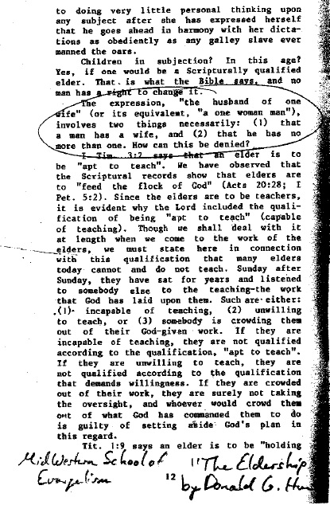
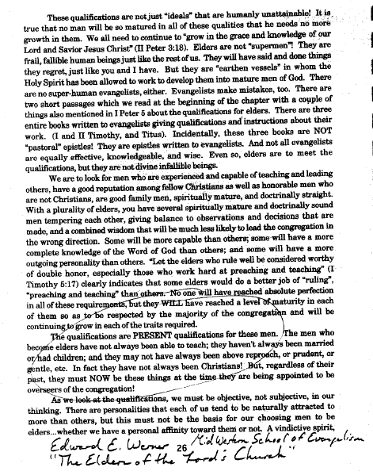
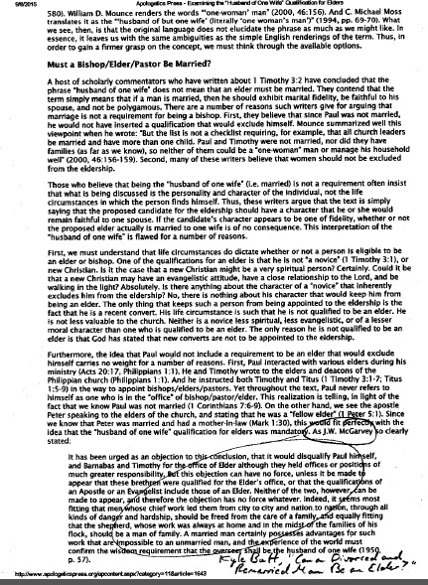
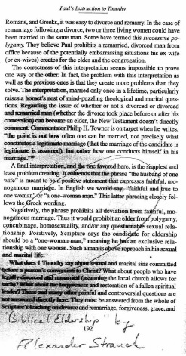
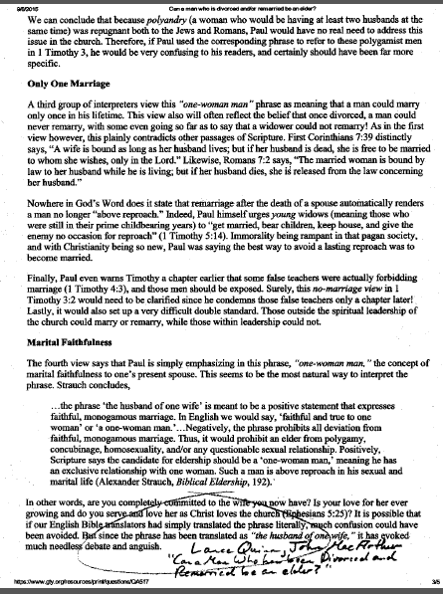
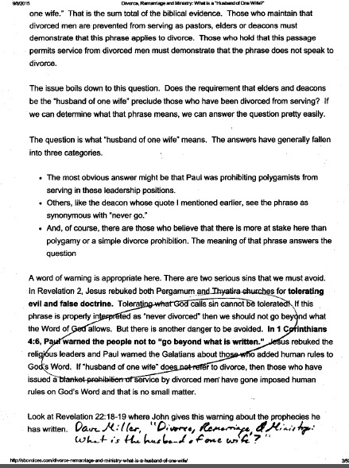
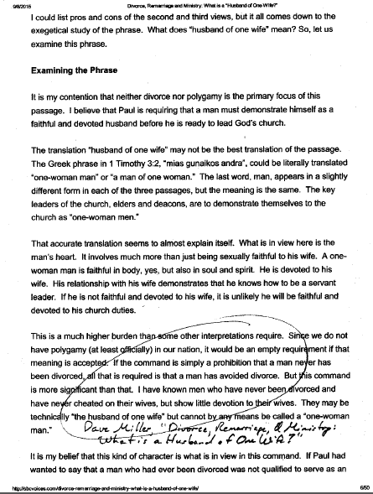
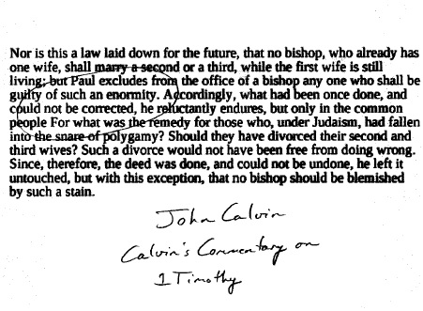
NOTE 2: It is commonly said that “desire” is a necessary qualification for an elder, yet that is not how the verse reads: “It is a trustworthy statement: if any man aspires to the office of ^{[a]}overseer, it is a fine work he desires to do.” (1 Timothy 3:1 - NASB) Otherwise, the point is not that desire is a qualification, but rather that what he is desiring to do is a “fine work”. Consider it another way: would it make any sense at all to have a deacon that did not desire his work, or an evangelist that did not desire their work? No. The point Paul is making is not that an elder desires his work (of course he does) but rather what he is “aspiring” (NASB) to do is good. Truly, “desire” is a de facto “qualification” that any church officer must have. This is also why Paul can and did leave out “desire” from Titus 1:5-9 from the list of elder qualifications in that passage; “desire” in and of itself is not a listed qualification but rather a fortunate reality for he who desires such a good work. Instead, desire itself can be safely assumed for any church officer.
Can a Widower Be an Elder?
By Josh Stucki

INTRO

I have recently re-thought my perspective on this issue. For a long time, I have looked at the qualifications of an elder from a technical-grammatical perspective, missing the forest for the trees.
When looking at the characteristics of a church leader, we are not dealing with a machine, but a man. These qualifications are describing the character of a man, not asking us to sacrifice the spirit of the law for the letter of the law.
Therefore, let us examine this question with a man in mind – the overall man – and honor Scripture’s “musts”, as we must.

OTHERS’ VIEWS
Now I must also say that the view I am about to espouse is not common at all in the Christian Churches / Churches of Christ. I cannot find a single major scholar in our brotherhood who outright says that a widower can be an elder. Some say “maybe”. Some say a man who is already an elder can still be an elder if his wife dies. Some simply do not attempt to answer the question. None also outright deny it. Ambiguousness is a tough nut to crack.

CAN A WIDOWER BE AN ELDER?
The question at hand all boils down to one phrase in 1 Timothy 3:2 and Titus 1:6 – “the husband of one wife” – and the present-tense predicate found in 1 Timothy 3:2, “must be”.
My previous approach was to mechanically conclude that “be” means right now and “the husband of one wife” means must be married – so, a man must be married right now – and that’s it.
Let me explain now why I now believe such an approach misses the point of the entire thrust of the passage:
First, this qualification is not talking about a machine here. When I was in the commercial work of computers (3/4’s of my adult life at the time of this writing), everything I did was about technical detail. One letter in a single line of code changes everything; one wrong mouse click and something horrible could go wrong. I still succumb to this kind of thinking on a regular basis.
This kind of thinking simply does not translate to human characteristics. We are not hard-wired machines (regardless of what the Calvinists think) of whom one technicality defines all. Instead, we are all mixes of various qualities, and the qualifications of elders are not describing each of these in minute detail. That would be impossible.
Paul here is describing the overall thrust of the kind of man that belongs in the eldership. Each of these qualities must be met – absolutely – it is a “must” – but they cannot be understood by mere grammar and mechanics.
Otherwise, what does “must be… the husband of one wife” mean not just to itself but with regards to the all the qualities to the office of an elder?
First, we can easily eliminate what “husband of one wife” certainly cannot be: a never-married man, a divorced-and-not-remarried man, a polygamous man, an adulterer, a homosexual man, or a man who is presently in the process of “dating around” (naturally, some of the above are in state of sin and others are not). But one thing is for sure – none of these unqualified men are presently with or about one woman.
Therefore, the only question that remains is, “Can a faithfully married man, whose wife died, become or remain an elder?” I now say “yes.”
In the Greek, “husband” is the same word as “man” and “wife” is the same word as “woman.” It is just as easy to read “husband of one wife” and it is to read “man one woman” or sometimes rendered as, “a one-woman man”.
Otherwise, is this man considering eldership still faithful to one woman? Is not “faithfulness” the higher requirement than just simply married? And would we not expect faithfulness in an elder than just a state of being?
As I have been in the ministry longer, I have come to meet men whose wives have passed and they are still faithful to them. They may not be technically married any longer (the Bible is clear about their right to remarry, no one argues) but they are still committed to that one woman – “a one-woman man.”
As well, a man who remarries and pledges allegiance to his new wife is also still a “one-woman man.” He may still think a great deal of his previous wife and treasures those memories (especially with any children they had), but now he has pledges his love to his new wife and if that is being evidently practiced, he still fits the qualification.

IS IT FALSIFIABLE?
Finally, is the above view falsifiable? It must be if it has any chance to be true. Falsifiability means if a proposition is true, then the opposite of the proposition must be false (if it is not, there is an error with the proposition itself).
The opposite of a one-woman widower would be a widower who has become homosexual, is dating around, polygamous, or dishonors his previous marriage while he is a single man. He is not presently a “one-woman man.” This does NOT mean a man who is merely dating around to get to know new potential mates is doing anything wrong. This just simply means that the opposite of a one-woman widower could be any of the above scenarios – and while some are sinful and others are not – they are all disqualifying scenarios for being an elder.
An elder needs to either be married (preferably not newly-married) to a new wife healthfully, or at most be dating one woman at a time, or none.
It is prudent that if a man does start dating a woman but is not yet an elder, that he puts his candidacy on hold to see where things go, in case the situation heads south and cause unneeded difficulty in the leadership.
Any widower-elder who starts to date should do so one woman at a time and with extreme caution to see where things go lest it cause any trouble for the church.

CONCLUSION
I apologize for my previous approach which may have harmed some unintentionally. It “missed the forest for the trees.” We cannot look at man as we do an engine in a car, but rather as God made him – and God set these qualities for man – not machines.
A widower can be an elder if he is still “a one-woman man”, be that to a new wife or his previously passed wife whom he still honors.
A man who is dating should likely put any candidacy on hold to see where the relationship goes. Any widower-elder who is considering dating should practice extreme caution, so that if the relationship did not work out it would not cause strife in the church.
Most certainly a never-married man, a divorced-and-not-remarried man, a polygamous man, an adulterer, a homosexual man, or a man who is presently in the process dating around is not qualified to be an elder. On this, no one disagrees.
QUALIFICATIONS FOR DEACONS
One Assumption Made Throughout This Study:
Deacons must be male (“men” – 1 Timothy 3:8). “Deacon” literally translates to “male servant” from the Greek. There are no “women deacons” in the New Testament. “Deaconess” is an improper rendering of Romans 16:1 (properly translated “servant” in the NASB).
Qualifications of Deacons from 1 Timothy 3:8-10, 12
Chart and Commentary by Joshua Stucki
Scripture | Qualification  (words via NASB) | Elsewhere in Scripture | Meaning | Grammar Tense
1 Timothy 3:8 | “dignity” | “semnos”  7) “semnos” – one of whom respect, submission is expected (applied to governing authorities, such as 1 Timothy 2:2 and Titus 2:7) | Literally, “submissive, honorable to their superiors, grave, serious, dignified”  Specifically, these designated servants are to submit to the eldership, as the qualifications for elders are immediately given before.  Just as the elders submit to Christ, so deacons submit to elders. | Present tense
1 Timothy 3:8 | “not double-tongued” | “me diligous”  Unique word used only here in the New Testament. | Literally, “not deceitful”  Not a liar, a man of integrity, says the same thing in all situations. | Present tense
1 Timothy 3:8 | “not… addicted to much wine” | “me oino pollo prosechontas” | Literally, “not to wine much being given”  Drink wine sparingly; definitely not addicted or drunk. | Present tense
1 Timothy 3:8 | “not… fond of sordid gain” | “me aiscrokerdeis” | Literally, “not greedy of dishonest gain”  Does not gamble, does not desire unearned money. | Present tense
1 Timothy 3:9 | “holding to the mystery of the faith with a clear conscience” | “echontas to mysterion tes pisteos en kithara syneidesei”  1) Mark 4:11 – “mystery of the Kingdom”  2) 1 Corinthians 2:1 – “testimony of God”  3) 1 Corinthians 15:51 – mysteries revealed  4) Ephesians 5:32 – mystery of marriage  5) Ephesians 6:19 – “mystery of the Gospel”  6) Colossians 4:3 – “mystery of Christ”  7) 1 Timothy 3:9 – “mystery of the faith”  8) Parallel understanding: standing firm in the faith given for once all the saints (Jude 1:3). | Literally, “holding to the mystery of the faith in clear conscience”  A man who knows what to believe and how to live.  A man who understands these things do not change.  A man who understands clearly the mystery of God revealed in Christ.  A man who has a clean/clear conscience.  A man who has control of his flesh and its desires. | Present tense
1 Timothy 3:10 | “must also be tested… if they are beyond reproach” | “dokimazesthosan…anenkletoi ontes”  Used 22 times in the New Testament.  1) Luke 12:56 – “to analyze”  2) Luke 14:19 – “to try” (as in, to test)  3) Romans 2:18 – “approve”  4) 1 Corinthians 3:13 – “will test”  5) 1 Corinthians 11:28 – “must examine” (self-examination, in relation to communion)  6) 2 Corinthians 8:8 – “as proving”  7) 2 Corinthians 8:22 – “tested”  8) Ephesians 5:10 – “trying to learn”  9) 1 Thessalonians 2:14 – “have been approved by God”  10) 1 John 4:1 – “test the spirits” | Literally, “let them be tested… being blameless”  A man proven not to be presently under discipline. | Present tense
1 Timothy 3:12 | “must be husbands of only one wife, and ^{[i]}good managers of their children and their own households.” | “diakonoi estosan mias gynaikos andres teknon kalos proistamenoi kai ton idion oikon”  These are the same qualifications given to elders in 1 Timothy 3:2, 4+5 and Titus 1:6.  See same word study and commentary on pages 4, 7-12, and 14-28. | Literally, “Deacons let be of one wife husbands their children well managing and the own households”  These are the same qualifications given to elders in 1 Timothy 3:2, 4+5 and Titus 1:6.  See same word study and commentary on pages 6, 9-12, and 16-30. | Present tense

Additional Insights to Qualifications of Deacons:
1) Elders and deacons share the same qualifications for marriage and family. One cannot say that a man can be a deacon but not an elder, or vice versa, based on these qualifications alone. A double standard is not permitted by Scripture. This also helps us realize that elders are not held to “a higher standard” than deacons in these areas. It is altogether a high standard, required of both types of leaders.
2) Paul did not give Titus qualifications for deacons, only Timothy. Although both Timothy and Titus were both located evangelists/ministers at the time (1 Timothy 1:3; Titus 1:5), and deacons were in existence elsewhere (Philippians 1:1), there is only one set of qualifications for deacons given in the New Testament.

